**Problem 1**

**(i)**

X is the MPG values from a normally distributed population.

**(ii)**

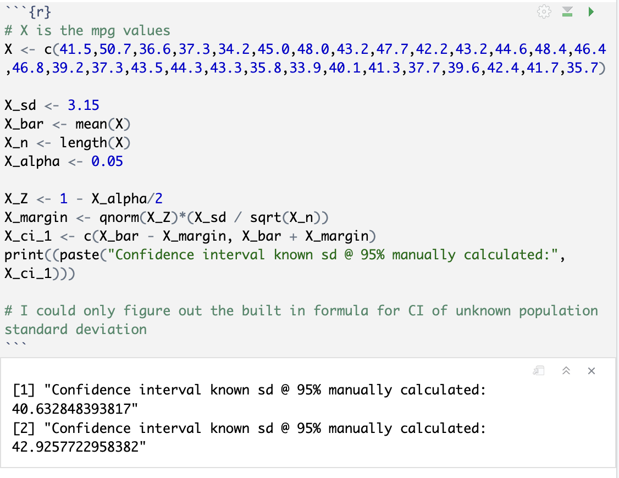

**(iii)**

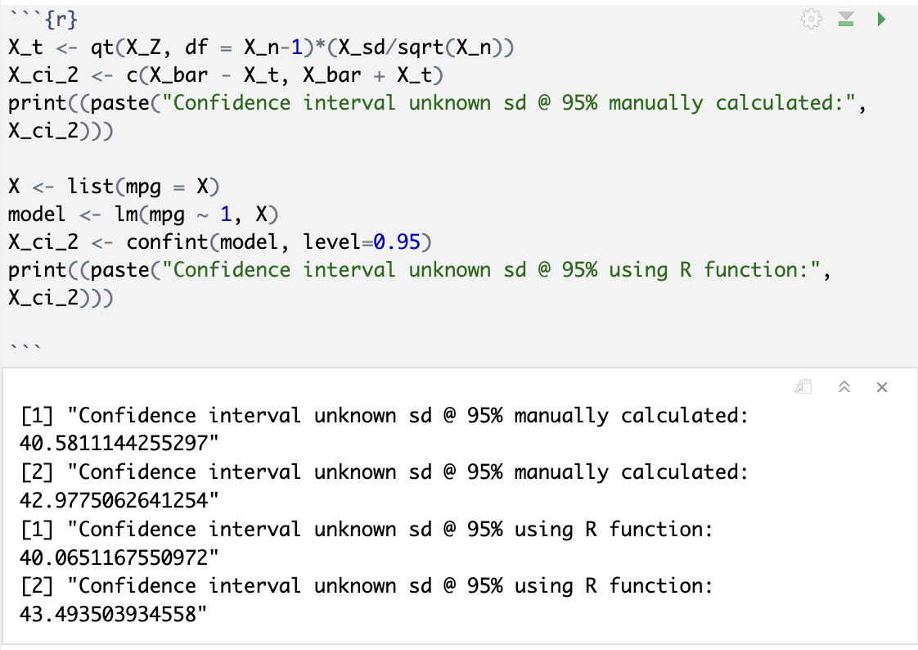

**(iv)**

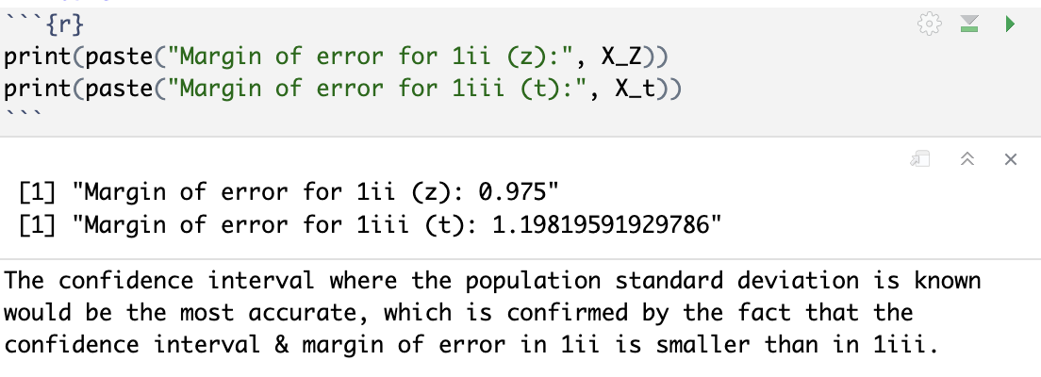

**(v)**

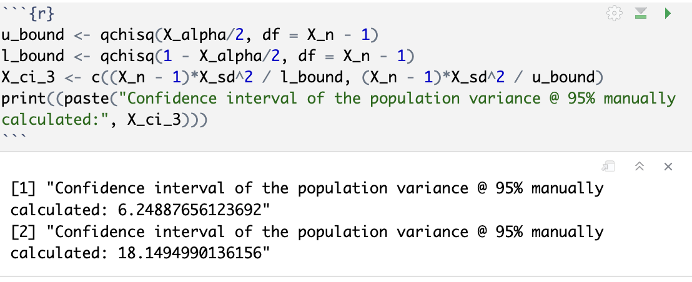

**Problem 2**

**(i)**

Y is if MPG > 40, where 1 = yes, 0 = no.

**(ii)**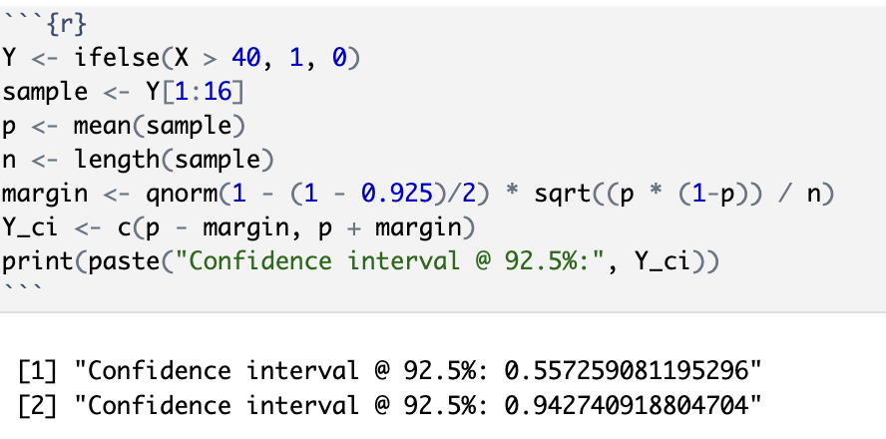

$E =z_{1-α/2}\sqrt{\frac{\hat{p}(1-\hat{p})}{n}}= 1.780464\sqrt{\frac{0.75(1-0.75)}{16}}=0.1927409$

$\hat{p} ±E=0.75±0.1927409= (0.5572591, 0.9427409)$

**(iii)**

$E = z_{1-α/2}\sqrt{\frac{\hat{p}(1-\hat{p})}{n}}=1.780464\sqrt{\frac{ 0.6551724(1- 0.6551724)}{26}}=0.1571495$

$\hat{p} ±E=0.6551724 ±0.1571495 = (0.4980229, 0.8123219)$

> p2 <- mean(mpg)

> E <- qnorm(1 - (1 - 0.925)/2) * sqrt((p2 * (1 - p2)) / length(mpg))

> print(c(p2 - E, p2 + E))

[1] **0.4980229 0.8123219**

**(iv)**

$E_{ii}=0.1927409$

$E_{iii}=0.1571495$

The process in iii, where we use all of the data points, is more accurate because its error margin is smaller. This means, if we want to draw any conclusions about the data set, we should use all of the data available.

**Problem 3**

**(i)**

> library(BSDA)

> x = rnorm(30, mean = 1, sd = 2)

> z.test(x, mu = 1, sigma.x = 1, conf.level = .95)

One-sample z-Test

data: x

z = 1.5752, p-value = 0.1152

alternative hypothesis: true mean is not equal to 1

95 percent confidence interval:

**0.929761 1.645439**

sample estimates:

mean of x

1.2876

**(ii)**

> N <- 0

> for (x in 1:100) {

+ x <- rnorm(30, mean = 1, sd = 2)

+ low <- mean(x) - qnorm(1 - .05 / 2) * 2 / sqrt(30)

+ high <- mean(x) + qnorm(1 - .05 / 2) * 2 / sqrt(30)

+ if (low < 1 && 1 < high) {

+ N <- N+1

+ }

+ }

> print(N/100)

[1] **0.96**

The proportion is approximately equal to the confidence level.

**(iii)**

> x = rnorm(30, mean = 1, sd = 2)

> t.test(x, mu = 1, conf.level = .90)

One Sample t-test

data: x

t = 0.70471, df = 29, p-value = 0.4866

alternative hypothesis: true mean is not equal to 1

90 percent confidence interval:

**0.5941651 1.9810346**

sample estimates:

mean of x

1.2876

**(iv)**

> N <- 0

> for (x in 1:100) {

+ x <- rnorm(30, mean = 1, sd = 2)

+ low <- mean(x) - qt(1 - .10 / 2, 29) * 2 / sqrt(30)

+ high <- mean(x) + qt(1 - .10 / 2, 29) * 2 / sqrt(30)

+ if (low < 1 && 1 < high) {

+ N <- N+1

+ }

+ }

> print(N/100)

[1] **0.89**

The proportion is approximately equal to the confidence level. THis is possible because the Student's T distribution is an approximation of the normal distribution, which the data actually is. It's made more accurate by our use of the correct amount of degrees of freedom (here $df=n-1$).